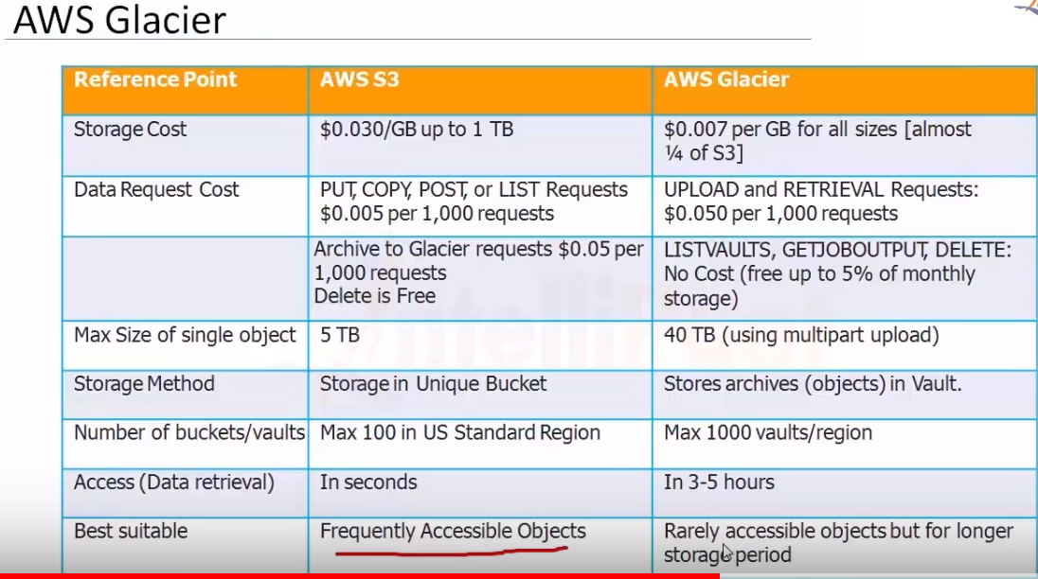

**Different storage options**:

Amazon S3 is durable object storage type.

Glacier: is archival storage type

EBS: block storage type.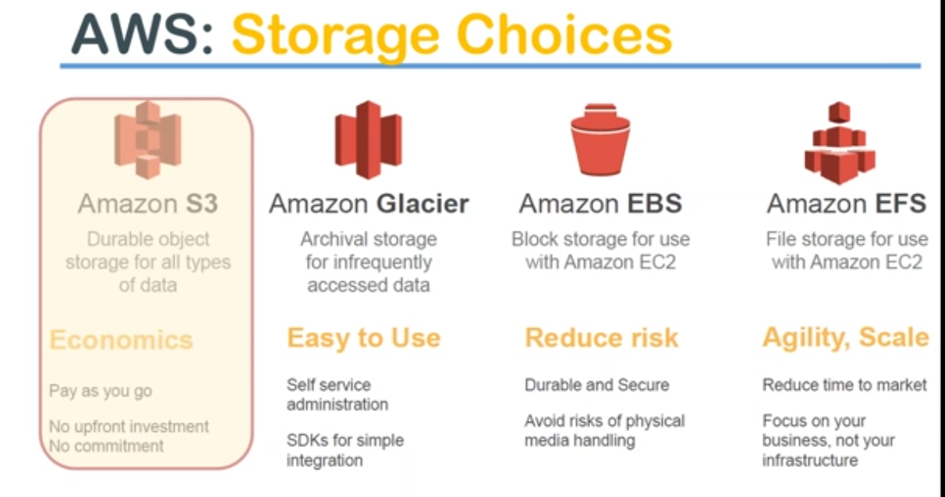

There is another way of looking at these Storage options, Amazon offers…

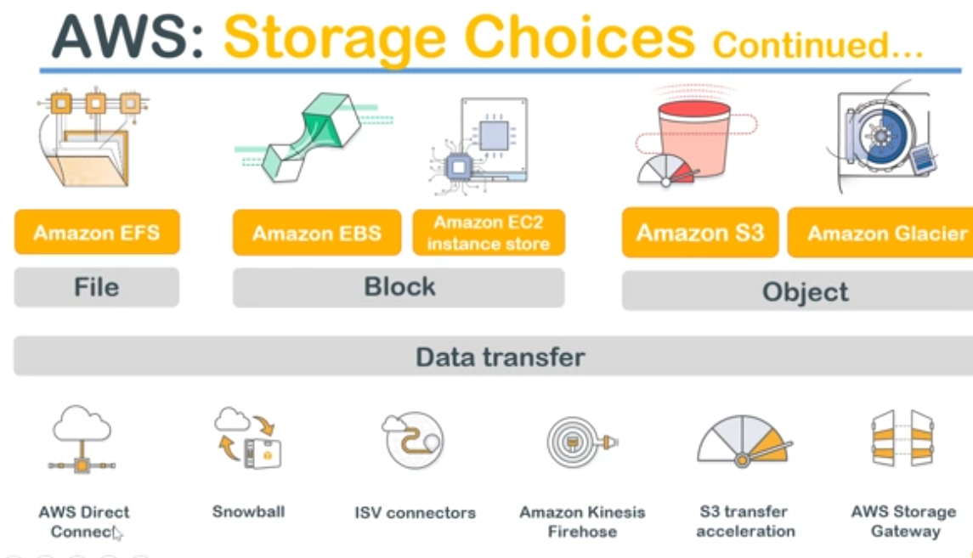

* Amazon has something called a **file based storage** 🡪EFS
* if you want to do some **block level operations**, you have these two storage options🡪EBS and Ec2.
* When it comes to object level storage i.e..., file based storage or a media file.., file can be anything a media file a video file or an image file or some kind of a database blog or even VDI image or snapshot or any kind of snapshots that you take in your operating system.

It can be anything... But should be a single object. If you want to store those single objects 🡪S3

* Glacier🡪 is your archival storage.

At bottom, is the data transfer methods that you have you have all these options to inject data into your Amazon storage.

**S3:**

Amazon gives you : certain level of commitment on

* what is the durability
* what is the availability and
* what are the security features...

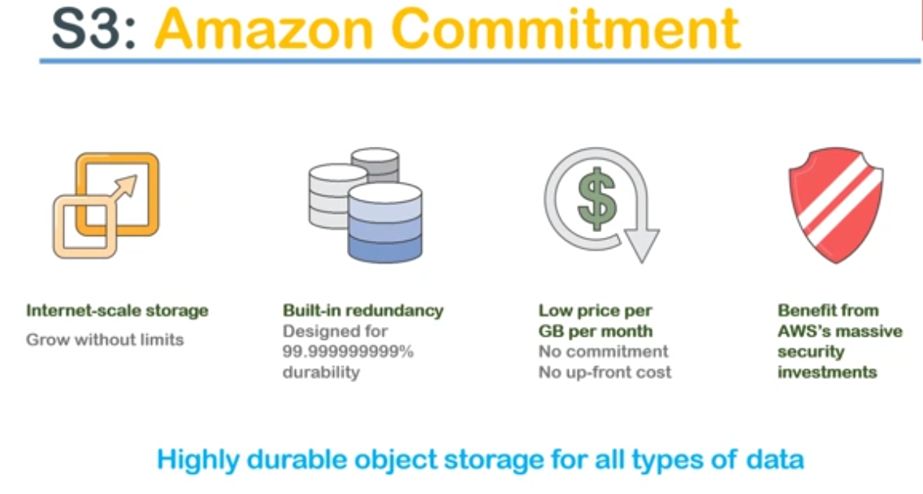

1. **It is an internet scale storage** and if you can grow without limits.

You can store literally terabytes of object size objects which are of terabytes of size data.

Your single image or media file can be a few terabytes in size and you can have multiple objects like that. or think of storing many millions of images..

b.) you can start your own image hosting service using s3 and you don't have to control the user, saying you have to upload 100 images per day or in a lifetime you can store only thousand images .

c. S3 storage keeps on increasing as you start using it and it scales down as well when you start removing data from your account and

d. you also Pay only for the amount of storage that you are using and also the data transfers that you are doing.

e. So upload is free and if you want to download data out of s3 , you are going pay small amount of cost.

2**.) built for redundancy** :

a.it has about eleven ninths of will durability built into it that means that it doesn't lose data that easily.

There is a calculation in Amazon website of you are interested in fun facts those kind of things then you can go and see it.

They say about in a few million years they might miss one file of stored in s3.

You can confidently store any confidential data and forget about duplicating the data or having multiple piece of the same data so that you don't lose it so that is a durability..

3**.)Low cost** is one of the lowest in the market.They charge about 0.01$/GB per month.

pricing is not exactly a number that you I would want you to remember but just remember that s3 is one of the cheaper sister is available in the market.

4.) **security**: there are multiple options to secure your files in the cloud.

a.) you can **encrypt your files** and upload it or after it is uploaded you can encrypt your files and

b.)you can restrict your access by having **fine-grained privileges**

c.)you can have a role based access.

**for example:** the HR department is going to show the all the confidential data of that employees in S3, then they can ensure that only employees and the HR group can access that data.

**Ex-2:** if your corporate data center or corporate headoffice, wants is trying to share some kind of a report or some kind of an information with all the employees in the world of Only their employees.. Then they can put it in s3 and say that employees of my organization can only visit it.

**use case-3:** a company wants to put out a media file or an advertisement about their product then in that case they can put it in the S3 and give access to all across the world.

We saw simply three business cases..

1. restricting within their own department.
2. then it is restricting all over the company
3. then is unlimited/unrestricted access to everybody in the world

These kind of different use cases can be done in s3 using IAM roles and policies

**Features of Amazon S3**

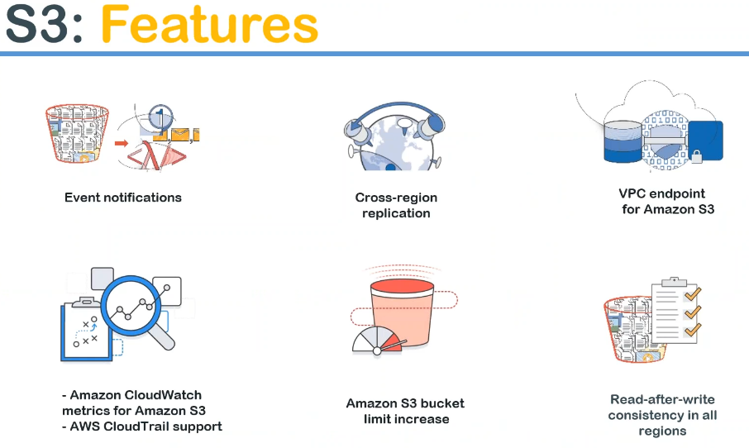

**Event notifications:**

**Example**: of image boosting website... So one of your customers is for uploading an image to s3 bucket then you want to be notified that some action has happened. So what you can do is you can do email notification or you can do some downstream processing say for example you want to identify what is in that image whether it is a person or an object ..

If it is a person if you want to notify your friends saying that person has uploaded an image do you want to like it do you want to share it do you want to retweet it or anything so you can do both notifications through emails or you can do some downstream processing using lambda or any other services.

**Event notification:** Anything happens in your bucket then you can get event likewise somebody deletes an object in your account or if it is an enterprise you want to be notified of any anomalous behavior in your bucket for example somebody deletes a critical file in your bucket you want to be notified of that so that is also possible by using event notifications...

**Cross region replication** This is replicating data from one place to another place as the image here signifies you can replicate your data from let us say Indian region to Virginia region by just configuring it in your console.

**VPC endpoints** that is a very very new and very secure option of accessing your s3 bucket.., what it means that is you can access your bucket through a secure pipeline from any of your other AWS resources.

For example you want to give access to your ec2 instances or servers or some other each of these resources to your bucket, then you can create a very secure endpoint or you get an URL which is accessible only from within your V PC or from within your corporate data center.

So that is how you secure the access to your bucket.., this is apart from your user ID access, encryption level access and R/W access. So endpoint for the or the source where you are going to access your bucket which will be secured when you are using VPC endpoint.

**CloudWatch** is nothing but a monitoring tool which:

* monitors your usage or
* whether who is accessing it and
* who is trying to do what activities using cloud trails.

So you can think of it as a monitoring tool for your bucket then you can use any of these options to watch out for actions and

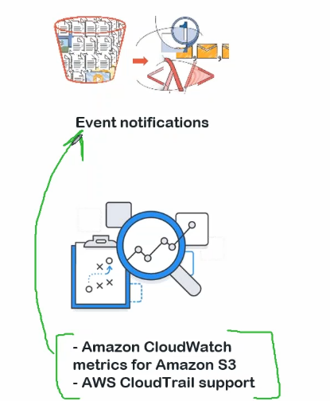

When anonymous behavior happens then you can do something and event notification.

So you can combine these two features to see what is happening in your bucket and try to trigger notification alarm and it takes actions by using lambda.

Features of s3 works very well with one another so you can combine some of these features to have a really advanced capabilities which is not available when you think of them as a standalone features.

**S3 bucket limit increase** sometimes some customers of Amazon still hit the limit of the bucket then what you do is you raise it ticket with Amazon support and tell them that this is my business case and I am going to need more storage or more capability in my bucket.., please provide those capability and ready to pay for it then Amazon will look at your business case and work with you to optimize your application and optimize the Amazon s3 storage for you so it is not a straightforward process a meaning is like this a ticket and they will do it they will look at your business case very closely because those limits are really high already and if you are hitting them they look at your business case you see if there is any improvement can be done on your side and their side ..If it is valid they will definitely help you to increase your limits .

Limit increase is not just for s3 bucket I can say it literally happens for all both all the services. All the services have something called a soft limit and once you start hitting that limit then you raise with ticket with Amazon and ask them to reach that limit

**Read after write consistency** let us say you are uploading something like a 5 gigabyte of a media file to s3 bucket and if you're doing it they're from India especially..., you are going to throw it to average internet speed not as good as compared to say South Korea or the United States ..,where the internet speed is like 40 MBps.. So you mean you're going to do 5 GB upload, you are not sure that whether your upload is successfully completed or not. So to overcome those kind of scenarios or what Amazon does is they give you an option something ...It is not an option this is by default..

Read after write only after the file is completely uploaded and consistency is checked across multiple copies, Amazon will allow anybody to read that file .So what it means is: write first only when your write is successful then you go ahead and read it. So the consistency of the file is ensured first then only you start distributing the file across all the regions or across all your users.

Until then you are not given a successful status of an upload until then you are not able to read that file So this way Amazon ensures gives a peace of mind for people who are uploading a huge files or multiple files at the same time.

So you can configure your systems to read this notification whether that status is okay or not after the upload and once the status is okay then you can start using the files.

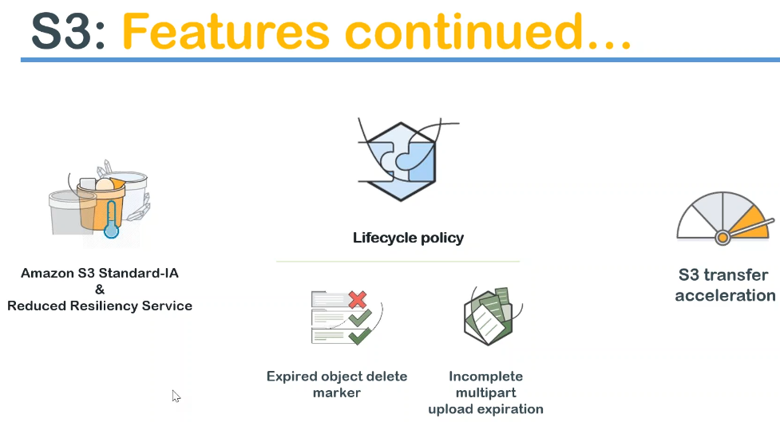

**multiple storage classes** 1.) standard storage one 2.) reduced resiliency service

* What I mean is the cost is different in each of them standard IA is nothing but infrequent access. Standard infrequent access of the cost of this storage is little bit lesser when compared to the standard storage.
* There is another of service reduced resiliency service ..This is also an s3 service and cost is also little bit different.
* Downside is that the durability and resiliency of these two features are lesser. It is not eleven nines it is something like a four nines and six nines.
* So you trade-off your resiliency for cost **so sometimes of customers want upload a file and they want to use it for only a one-week or something** they don't want to have eleven nights of usability then people start using something like a reduced resiliency service or an standard infrequent access storage.

**LifeCycle policies**: you can mark certain objects to be deleted.

* Ex: after one month nobody is going to need that file then you can automatically Configure lifecycle policy saying my objects **one month old objects in my bucket or it will be marked for expiration** and **three months old objects are to be deleted** which are marked for exploration.
* it goes like this you upload an object and after one month you upload 🡪expiry and after three months whichever objects are marked for expiry those objects **alone** will be deleted.
* The reason that is which is looking for that expired marker is some objects will be Older than 3 months which should not be deleted. So, your lifecycle policy looks for that Markee and then deletes only the tag which are marked for deletion.
* So, using lifecycle policy you do something called an auto-clean up. You don't have to clean your bucket whenever people are putting lot of objects your bucket becomes very difficult to manage with millions of objects.

So by using lifecycle policy you do auto cleanup and make sure your cost also comes down and managing your packet becomes very very easy .

* There are times that, when you upload something and it is incomplete .Sometimes people don't come back and finish the upload. So you want to create a life cycle policy to delete those incomplete uploads also so that they don't occupy storage and incur costs for you.

T**ransfer acceleration** : think of it as like highway for you.

* instead of uploading in one stream, Amazon allows you to upload in multiple streams by using a new service called s3 transfer acceleration.
* This is a little bit costly service especially for uploading.. What happens is, if you want to upload it to a let us say from India I want to upload it to an American region by using this service.
* I will upload it to Indian s3 region, Amazon will internally move it move the data across their data centers and put it in the American data center. So transfer acceleration is a little bit a paid service or costlier service when compared to the normal standard upload.
* So if you have more data and your customer says I want to upload it as soon as possible.., then this is a service that you can now give it as an option.

**different storage Classes**

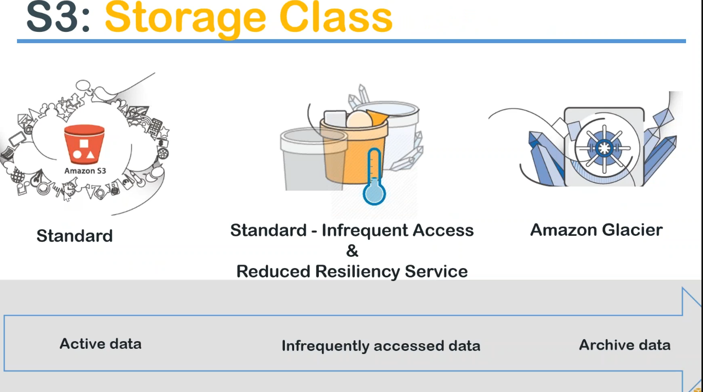

**standard data** that is active data, which you frequently access and you want to have immediate retrieval for this data.

**infrequent access data** if you have this increment requirement and over data to be stored then you can use any one of these services.

Here you trade off resiliency here you trade off durability... The nines are the difference .

If you don't want to have infrequent a course.

S3🡪Access every day. Std.Infrequent🡪every week you Glacier: 🡪store the data for seven years but you don't know when you are going to access the data.., then you push all that data to Amazon Glacier.

This is a very very cheap storage.

Cost🡪 3 dollars ……………………..in between……………………….. 1 $

what is my cheapest storage over long term ?? or cheapest storage for infrequent data ??and what is the storage available for constantly accessed data??



**s3 bucket?** and what are the buckets objects? and how to access ?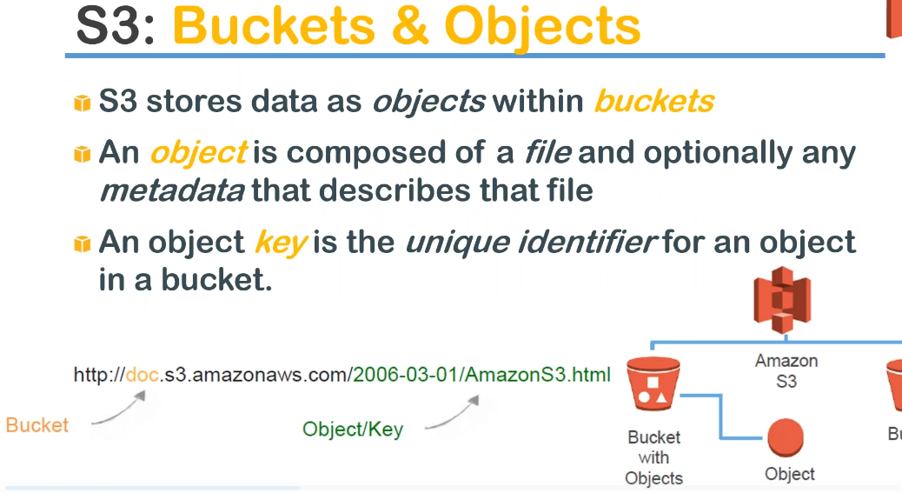

* A bucket is nothing but a collection of objects. S3 stores data as objects within the bucket.

object is composed of a file and optionally any metadata that describes that file.

* **example** I'm uploading media file, image file then I can upload a metadata saying this is a JPEG image and if I'm going to upload a PNG or TIFF image then I can say a metadata is that it's a jiff image or

if I'm going to upload a video file I can say this is MPEG encoded or MKV . That kind of metadata I can store.

* Every object I upload will get a key, which is very very unique and also, every object I upload will also get an URL ..which through which you can access that object

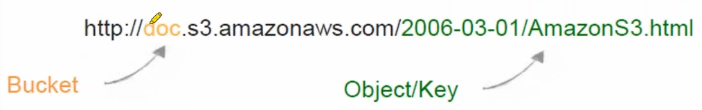

* HTTP ,followed by the bucket identifier and then this is a standard URL(s3.amazonaws.com) and after that is your this is something that you can choose **whether you want to have a directory structure with or you have a directory structure based on your hierarchy.**
* Example: company name, below that is your department and below the department is your team name and below the team name you can have different files based on dates or any other combination and finally is your object key

**pictorial representation**

Amazon s3 and below that you have buckets and under the bucket you have different objects.

* **Note:** every object that you uploaded to Amazon will have an unique URL like this and using this URL you can access that object from anywhere in the world.., assuming the permissions have been provided for that object.
* URL every object : it is only reference point. URL will not have any information of object.

**S3 events**

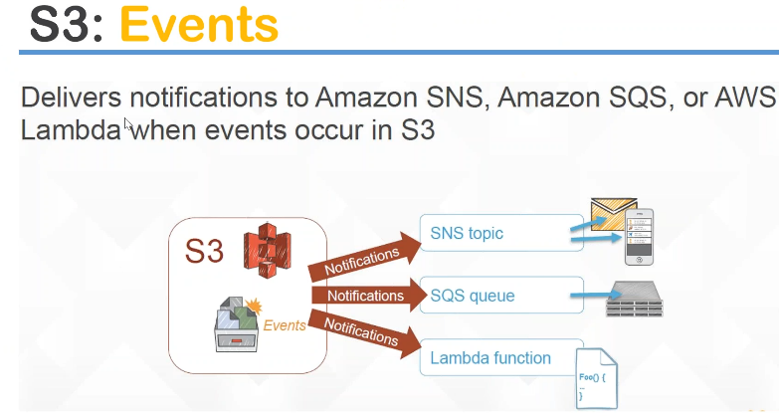

whenever s3 upload or delete or anything happens, you can push notifications to an SNS topic so you can get a mobile notification or an email notification.

or you can process it using a downstream queue and also

you can process it using a lambda function.

**example** you want to resize the image, whenever an upload somebody is uploading a 10 MB megabyte 10 megabyte file you want to make it into multiple sizes, so people in mobile people attend tablet people in computer can also see it in an optimal.

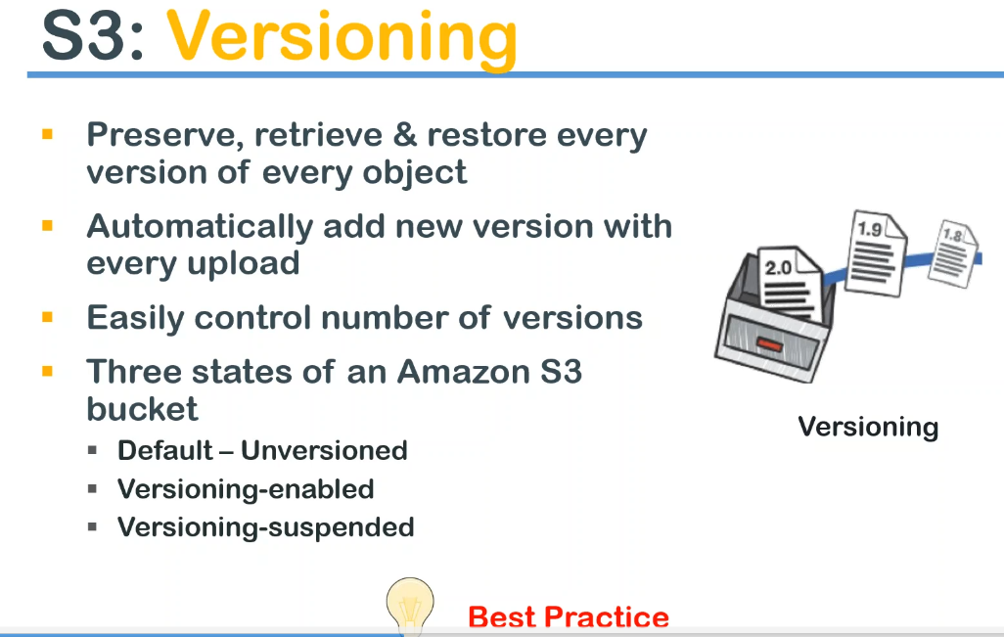

* let us say your creating an object and you want to keep track of what are the changes and so that you can go back to the previous one then we do something called the versioning .
* Enables you to preserve, retrieve, restored every version of the object
* Example: latest version has been corrupted for some reason or has some undesired effects on the contents, then you want to revert back to the older version then you go to the versioning tab and say it is closed or download the world version and again upload it so that is how you restore the old versions.
* versioning is done automatically for you whenever you upload the same object again then amazon automatically updates the version numbers and it keeps updating every time you upload a new version
* It is very easy you don't have to literally do anything you just have to go to a checkbox and enable it.
* By default, you have three states of versions:

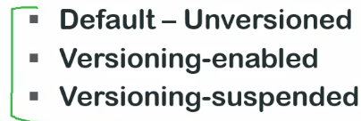 .

* This state that means that you have enabled versioning and let us say after enabling versioning for six months you suddenly decide that a for that bucket, you don't need versioning anymore so you can do something called suspending the version.
* In other words once you enable it there is no way that you can stop it you can only suspend it
* Why you get you end up in a third state which is a set as suspended is .. there is a small cost associated because multiple copies of the same file is kept in your bucket, and there are some metadata that is kept in your pocket before versioning and there is a small additional cost associated with it.
* This becomes bigger and bigger whenever more and more objects are getting stored in your bucket.
* So sometimes companies want to think that I want versioning only when IGOLIVE and after I go live I'm in a steady state… I don't want to micro manage the files. So they go ahead and stop the versioning.
* If it is a critical file always DO versioning because that is the only way you can retrieve or any of damage to file or any accidental deletions that happens in your bucket..

**Otherwise there is no way you can retrieve a deleted object from your bucket.**

**best practice:** enable versioning if you really want it and leave it as it is if you want it so that is your best practice.

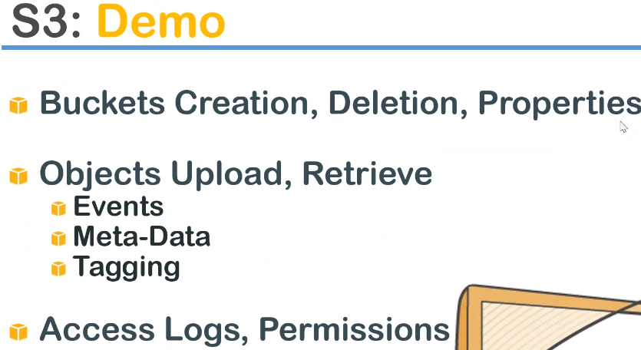

**tagging** : tagging is a human friendly metadata. You can use to understand what is the data that is being stored and whether you can use the tagging to calculate the cost associated with it .

**enabling access logs** to your bucket: This is a typical web server access logs whence you enable it, Amazon will start recording who is accessing your bucket or what are the actions they are performing it in your bucket.

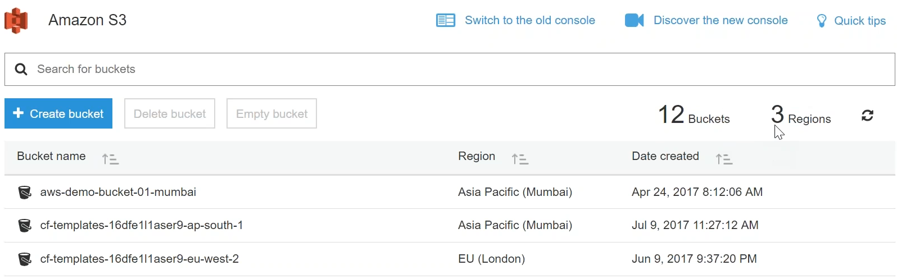

S3 dashboard: it lists all my buckets in my account and it shows that I have buckets in three different regions..

Amazon s3 is in global service there is no choice of region that you can choose.

Amazon s3 does not require a region selection .You can choose to store an object in a particular region **For example:** for this bucket, I have chosen a Mumbai region but that does not mean that I cannot access this bucket from and US region..

but putting it this in particular region produces your latency because I am in Mumbai I'm in India and for me accessing this bucket it gives me less latency… if the data is closer to me so that is the way you can choose which region you want to put to your objects.. but otherwise you don't have to choose a region at all… it's global and it is available all over the globe.

so if I want to create a bucket I am going to click on this option and it gives me this dashboard of where I will create parameters and as it says here you are going to enter and DNS compliant bucket name that means you cannot have special characters you cannot have a lot of dots you cannot have underscores those kind of things it will show me in warning say for example today I am going to say galaxy as you can see if I put a capital name it says uppercase it's not allowed and you can see that when it is a lowercase or a number and you can have only three to 63 characters long and if we let us say I put an underscore here it will again complain about it and if I put a symbol also it will complain about it thus the symbol comes to knock it yeah there you go we cannot have symbols like that and it will complain saying that those things are not allowed I am going to save see demo bucket and you should also remember that buckets are global in nature bucket names are global I cannot use the same bucket name as somebody else has say something called demo okay that must be something like AWS demo bucket okay we are not we are not sitting the those options anyway it is not too private right now let us go ahead and create it okay I am going to leave it as my because I am in Mumbai we will do a cross like replication or cross region replication then we will create another bucket in the United States pigeon and I am NOT going to copy anything from my existing bucket this is a nice option where you want to copy some data from an existing packet then you use this option so for now I'm going to leave it as empty I'm going to click on next and it is asking me a lot of things remember versioning we talked about versioning so I am going to click on this and enable versioning for my pockets see there are two options only enable and suspect there is no stop or there is no cancel or anything like that so I am going to enable versioning and click on save and remember the access logs I spoke about set up access logs that records and provide details about your access requests so I am going to enable this as well and if I am going to enable it it is asking me where I want to put my access logs so what I am going to do is to see if I have any other bucket which is ready to deceive my access logs as of now I don't have it so that is a problem because I have to choose a bucket ok let us come back and access a enable access logging later that we disable it for now because I don't have a bucket that is the reason I'm saving it and tags usually you use your tags to track your cost and if you want to know what is inside your bucket so let us go ahead and add a tag I'm going to say name and then I'm going to say this is s3 demo okay this is completely user friendly you can give whatever you want there is no restrictions I can say contains files images so something like that so we have done those things you can see that a check mark here that is signature and this is disabled there is nothing but your logging is disabled versioning is enabled and tagging is enabled so let's go ahead and click on next here it is well and giving permissions I sent you as an owner of this project I have all the permissions if I want to give permissions to the public then I am going to queue these options as of now I'm not giving any permissions to this and as of now I am not permitting any log delivery or anything for this bucket so I am just going to leave it as default that is do not grant s3 log delivery group I do to that public via taxes leave it as it is click on next and it gives a nice summary of water all the options that we have chosen so far the name and region the properties we have chosen and the permissions we have given as you can see only I have access to this object and public permissions and system permissions are disabled so I am going to click on create bucket if you want to remember there were two twelve buckets in my count I'm going to click on create' and see what happens now okay you can see that there are 13 buckets and same number of regions if we scroll down to the bottom you can see it is a Lexy demo bucket and it was created in July 22 days time with this so I'm going to click on that now as you can see in a minute yeah you can see that my bucket is empty completely so I'm going to upload an object to my packet right now so it gives a nice interface like this add files what I'm going to do is usually have some amount of junk data to upload let us say I am going to upload this image now click on open so you can see that it is listed that image let me go ahead and upload it at the bottom you will have this progress bar which shows you how much of a products happened and you can see that it is already completed the one successful art and you can see that image is already available here so if you just if you want to create a subdirectory all you have to do is this and I am going to say the demo subfolder and click on save and click on this and you can again do an upload here as well add files let me choose something else I want to choose pictures save the pictures nothing I have Escamilla more demo it'll search for here usually I have some images ok yeah here we go I am going to upload this for not full image that you can see here I am going to upload that open let me upload one more object add files and let us say I am going to upload this image and upload you can see here there are one in progress to successful I hope at least through chosen three uploads so far you can see all three are successful and you can see my objects here so if I click on this object it will show me the properties of this object and here is the URL of that object that is available here so what I'm going to do now is I'm going to make this object public as you can see here before making this object I am going to copy/paste this to Earth and the browser it's a simple expect I am going to press ENTER and it will give me permission denied a message as you can see I use an access denied access denied and requested ID is this an access denied so anybody with an URL to your offsets will not be able to access it even if they are able to catch your URL they are not going to able to access it unless they have permissions to it so I am going to make it public so meanwhile what I am going to do is I'm going to put it in the blower chat window so you people also can access it and see I am going to make it public now I click on make public and it is public now I'm going to open another browser window and try to access it so voila you can also try it now so this is how you provide access to a bucket to a public we now given word rate a word read permissions not writable word read permissions to a particular object so what we have basically done is we have created a bucket we have uploaded as an object and for that object we have enabled versioning we have enabled public access and we have distributed the URL for public other people to access it so what I am going to do now is I am going to create a simple file let me see if I have a simple file so that we can demonstrate versioning so what I'm going to do now is try and see if we can have a very very simple file so that we can demonstrate the use case of worsening just give me a moment I am trying to find the file I usually have it ready but apparently I'm not able to find it quickly okay this is the courses I usually have our sample histamine files yeah I'm going to write a new or data file here that is not back here okay sample you can also fry that sample version file I'm going to say what I'm going to say is h1 I'm just creating a small HTML file so this works very nicely this is file version v1 and then I'm going to post a stream with tank I'm just creating a file you can do anything you want I'm just going to save this and what I'm going to do is I'm going to upload this into I'm going to create another bucket here another subdirectory in other words version test and I'm going to put the version test upload my file it was courses sample HTML files sample version text okay let us rename it as HTML rename rename rename okay I am going to upload this stuff and stick on next and they're just asking me whether I want to give any word rewritable functions exactly it's like strict deployment so I'm going to say grant public read access to the subject because I what you people also to access it I'm there when I choose this it gives me a nice warning saying this object has publicly taxes everyone in the world can read access click on next and I'm going to see here it gives me storage class options whenever I'm choosing an upload it is asking me just look at it you know why let me choose this I can demonstrate it somewhere this is as easy as choosing a storage class in s3 or developers this from sander I just click on standard ia and then I don't want to do any encryption right now and I don't want to choose any metadata so amazing understands that it's an HTML file and it is asking me additional properties so leave it as it is if you don't want to change anything leave it click on next and it is giving a nice summary and keep on upload be sure to see the object anytime now one object upload in progress great let me click on this and let me make this public also let us forcefully make it public okay this is the URL let me go to the browser okay here we go put it in the browser and I'm going to put it in the chat window also and so here I'm going to click on properties and for properties you can see here in this time in the particular file properties this particular file I mean the properties you can see here the storage class is chosen as standard ia and I did not use any encryption and for this object I did not choose any encryption so this is also empty and if I go to permissions it will show me all the letters of public access here it is everyone is yes and everyone can read this object they cannot read the permissions of this object they cannot write functions of this object but they can read the object itself so you see here this nice little drop-down okay not yet hit refresh I'm at the top you can see that this version is enabled you can see this is the latest version and it shows it like that now you can see I uploaded version 1 let me go ahead and edit my object here I am going to edit it I'm going to open it with let us say notepad itself that is the fastest way to edit these things just drag and drop I'm going to edit 8 it says for example from version 1 I am going to change it to version 2 out I'm going to save it and I'm going to upload it away into the same version test bucket let us go ahead and upload it add files motion test upload okay I'm going to it is completed upload I'm going to click on that and I'm going to go here and see what is happening here you can see here there are two versions now and if I access the anybody want to refresh those roses and see what is the version and let me know anybody has already tried it oh I did not give public access for this new of object upload let me go ahead and give it a flick access for this file again okay it should work now so you can see here I am already explosion - I have deployed the latest version and you can see the version - and there are some questions in the chat window what are we doing in time okay we have about nine minutes so for uploading in s3 you don't need any key or anything because it is your account your uploading and you don't need any key for that or you don't because we have logged in with our user ID and password and we are accessing it through the process if you are going to upload through a program or then another interface or from a third party then you will need the access key and security key to upload those things so and what I'm going to do is I'm going to show you access logs I am going to hopeful that it will be generated usually access box takes about 5-10 minutes to get rolling so let us go ahead and create another bucket in my route I am going to create another bucket and say let's see demo access logs I am going to use this bucket I'm creating a bucket just to store my access logs I'm going to put it in Mumbai region click on next and I don't want any of these things you can enable this also for access logs logs also will be logged but again it will ask me to choose the packet let me not do it now let me do that later and I will just go and say here in access logs for VALIC see demo and click on save click on next and I'm not going to give any of you permission here okay click on next and click on create budget now the bucket all it should have been 14 I guess yep the add a book that you change it I'm going to go to a galaxy demo bucket and go to properties and go to logging see here it's a text every time and it says disabled this will do not refresh for you guys okay I'm going to enable logging for this for this bucket and I'm going to type virus it here with this okay and when you want to or I mean it is easy to have a prefix so that you can easily run through it type of prefix that Amazon s3 can assign to all the logs that you are creating so I'm going to say just demo that is going to be my prefix demo - or what is the today's date I can do that as well or leave it as it is I mean this is the user friendly prefix for all the files that will be created in this bucket so I will know what is happening and where the logs are getting generated from click on save okay awesome we have enable versioning we have enabled logging and we just have to wait for some time and if I can request you guys to hit the URL a couple of times so that we tend to see the access logs getting logged it is fittest only my URL my IP address it will be very boring so all of you can request just hit this URL once again you should to see it and meanwhile let me show you how to rollback aversion on a fridge demo budget and we have version test folder here and if we have this file I'm going to click on this file and you you have all these properties here and you have this latest version so if you want to roll back to the previous version then multiple options will be listed here then you are going to download it and again upload it that is the one of the options that you have to roll back to your previous version or what you can do is I can completely delete this that is the latest version then make this as the only available version for this URL so either way you have two options of rolling back download the older copy and again upload it so that this looks like the latest version or delete the latest version either way it would work for you so that is about enabling I mean rolling back to previous versions and if you want to change storage class for an existing object so for example this is with some one of the objects that we uploaded and you can see here the flow is a class is a standard I want to change this one now so click on this one and click on properties ok not properties wait a second I should be able to change it not here one second no no no not this one let me go back so I is the properties window I'm not able to find the properties windows wait a second guys I'm a little bit a large stone where is the option to change the storage press one object alright yeah from the console it is not possible after you uploaded from the command line it is possible you can change the permissions of the object only from the console you can upload it and then when you are uploading you know that your right-click option no not to my knowledge or we have where's right Thank You mr. Hannemann yes you can have it here yeah wait you have all these three you can choose anything rhythmic you say you Sicilian see there is no absolutely there is no what shall I say there is no difficulty or there is no action apart from choosing what options you have to choose there is a Mazon doesn't force you on which object has to go to reduce acidity which option has to go to college class you get the complete freedom to choose which has to go where and this is another thing I wanted to show and let us go ahead and see if our access locks bucket has anything happened the demo access logs it usually doesn't store as quickly as this one I mean it takes about some time for the access logs to be recorded and then sent here usually it takes about 5 to 10 minutes or something like that let us go back to over presentation and see what else we have here for today ok we saw bucket creation and ok I can show you the lesson we saw about how to change the properties modify the properties we saw up to upload it how to retrieve it through the browser or how to download it the download option the Chiefs are there ok let us we spoke about metadata understanding and the metadata I will show you what are the events now and we spoke about all these things let me go back to the console and show you how to delete and do events your smokin solo session to your oldest tick marks will exceed demo bucket and then let us say I want to delete this object it is as good as going ahead and delete of this is did it all objects let me click on that to do okay right-click is the best option once again I guess right click and then click on delete that's one option or you can select this object under versions control you will have one more delete button that also you can do that is how you delete it let us go ahead and enable events if you scroll up and I will chosen the primary bucket and if you go to properties and if you scroll down to the bottom you have a lot of things on let us go ahead and click on events and I want to create a new event that is add a notification and what type of notification Amazon says you want me to put it is it is an email notification and whenever somebody deletes it somebody's Desa put I want to be notified and I don't want to have any prefixes of now and it is asking me where do you want me to send it to as of now I don't have any topic that is a simple notification service is the service that we use for email notifications and I don't have anything oh good I have something okay this is going to be little tricky how do I explain this I mean usually a topic is needed if it is topic is money not less than you have to click on this one ad is in this topic here iron oh I need in topic you guys let me go ahead and quickly create an s3 notification object topic or it will be confusing you guys do tell me yes or no if you can follow me I will go ahead and go ahead and create a topic and email notification we can create it otherwise what you need to do is I can use an existing one which is already pre-configured I will take your feedback if you want me to show it the SNS is a little bit different topic I didn't want to show it right away okay okay X confusing okay what we can do is we can see SNS traffic another day and we can come back and configure notifications it is nothing but all that is you will get the topic identify here like you see I have a notified topic like issue to monitor on I have to do is click on this and click on save and whenever somebody puts in object whenever somebody there is an object this is not okay yeah that is what happens exactly so you will need to put validate the permissions on the destination topic do not follow actually publish so you have to go to ec2 and allow it hello s3 to send notifications to that so you create it and come here and click on save that is what you should to here so this is how I would usually configured s3 is notification and you have other options also you can do lambda function if you have a lambda function returned in your account you need to give that URL here or if you have an sqs topic usually sqs is an application a queue management service usually they take and file and process it not for images and for images I usually use a lambda for something like face recognition spine recognition object recognition those kind of things I do in lambda and SNS is something like a notify saying of object has been uploaded or denied or rejected so those are the different the notification so as you do and this order this is where you do that and then just for your information this is the requested page account what it means is let us say you have a very big file in your pocket and you want to distribute it or to a lot of people and you don't want to pay for the bandwidth that could be charged if there you are going to allow them to pay if you are going to use that and you want to share the cost with your who is accessing it then you go ahead and enable this option that is enabled requested page what happens is if you have an Amazon account you will be to login with your Amazon account when you're accessing this object and any costs associated with accessing these objects are streaming this object will be tagged to your account so by default anonymous access will be disabled whenever you do this because amazon wants to know who is accessing it so the cost can be passed on to that person so that is more or less that definitely and I have seen it at least and certification question on this option on the wordings might be different but more or less they will ask you this question in other words pass on the cost to whoever accesses this object so that is what all you have to do is click on this and click on save and automatically anonymous access or free access whichever I have created will be disabled to see for example here it is enabled if you want to try this object now you will most probably have some problems with it see here access is denied all anonymous access will be by default disabled whenever you select requested face so we saw those things and we are already running out of short of time so I will leave the access logs as it is under tomorrow when we come back you should definitely be able to see some logs register there and we can continue the classes from there for tomorrow so for now we completed most of these things by tomorrow I'll set up an events SNS notification also for so that we can use it and trigger an SMS notification not SMS SMS notification and we can use that so yeah and we will continue to see cross region replication static the posting and those kind of things are tomorrow onwards and continue on the s3 classes and yesterday's video is there I just wanted to slightly if it is to remove some unwanted bits and after that I'll upload it and you should be able to see today's video also as soon as possible well you have any questions I'll wait for you guys who speak up and try to answer that